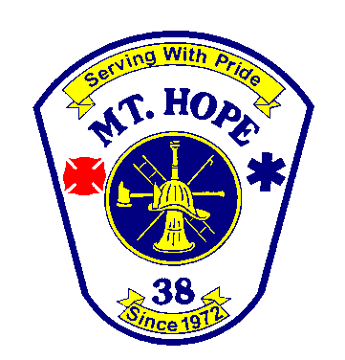
Mt. Hope Community Fire Department Station 38

Subject: Wearing of Fire Department Dress Uniform

Purpose: To prescribe specifications for fire department uniforms and establish rules, regulations and conditions of use.

Policy: Uniformed personnel will know and abide by the uniform standards specified herein. All standards and rules that pertain to uniform regulations will apply to all members anytime they are wearing the fire department uniform.

Authority & Responsibility

- The Fire Chief is responsible for establishing uniform specifications and the rules, regulations and conditions for use.
- Supervising officers are responsible to ensure that members conform to the Departments uniform standards.
- Members who refuse to comply with uniform standards and directives may be subject to disciplinary action up to and including dismissal.

General:

- Wearing of the fire department uniform should be a matter of personal pride to all personnel.
- The Department has 3 primary dress uniforms

- Chief Officers
- Company Officer
- Firefighters

- Only uniform items issued by the department or authorized by the Fire Chief are allowed to be worn
- Modifications to any uniform item must be approved by the Fire Chief or his/her designee.
- Fire Department uniforms shall be worn during designated times only. (Visitations, Funerals, Banquets, Special Events or other functions approved by Fire Chief) All other wear is strictly prohibited.
- Uniform clothing shall be kept clean and wrinkle free.
- Members shall wear only badges furnished by the Fire Department or shall have approval from the Fire Chief.
- Members shall not remove or alter the identification markings from garments.
- All members wearing Fire Department uniform shall remember they are representing Mt Hope Fire Department at all times and shall conduct themselves in a professional manner.
- Members who have not been issued a Fire Department uniform shall wear church attire clothing. Ex. Black dress paints and White dress shirt and tie if available.
- All members who have been with the department for 18 months or longer and is in good standing with department and meet all current guidelines based on Mt Hope Fire Department operating guidelines shall be issued fire department uniform.

Chief Officers:

- All Chief Officers shall be issued 1 full class A uniform. This includes short sleeve white shirt, long sleeve white shirt, solid black dress pants, black tie, black leather shoes, black belt, black dress coat, dress hat and all brass hardware and insignia’s.

Company Officers:

- All Company Officers (Lieutenants and Captains) shall be issued white long sleeve dress shirt, black dress pants, black tie and all brass hardware and insignia’s. All company officers please wear solid black dress shoes and solid black belt when wearing fire department uniform. These items will not be provided by the department.

Firefighters:

- All Firefighters shall be issued navy blue long sleeve dress shirt, navy blue dress pants and black tie. All identification markings shall be on uniform prior to receiving uniform. All Firefighters please wear solid black dress shoes and solid black belt when wearing fire department uniform. These items will not be provided by the department.

Proper Attire For:

- Visitations – Chief Officers shall wear white dress shirts with proper hardware and insignia’s and black dress paints. No tie is required. Company Officers shall wear white dress shirt with proper hardware and insignia’s and black dress paints. No tie is required. Firefighters shall wear navy blue dress shirt and navy blue paints. No tie is required.

- Funerals – Chief Officers shall wear full dress uniform with proper hardware and insignia’s. (Dress hat at Chief discretion) Company Officers shall wear white dress shirt with proper hardware and insignia’s and black dress pants. Dress tie is required. Firefighters shall wear navy blue dress shirt and navy blue pants. Dress tie is required.

- Banquets and Special Events – At the Chiefs Discretion. Based on type of event. Please refer to Fire Chief before you assume.

